Jeremy Drury and Brian Scheper

CS405G - Database Design

10/30/13

1. The database should contain tables for customers, employees, inventory, order history, and a shopping cart for a customer. The customer entity would have attributes of username, password, customer name, email address, and shipping address. The employee entity would have attributes of employee ID number (eid), password, employee name, and employee status (such as staff/manager). The inventory entity would have attributes of item number identifying each item uniquely, quantity of each item in the store, price of each item, and promotion of each item (if one exists). There is an order relationship between a customer and an order, containing the username and the order number corresponding to that user. The order entity would contain the order number, the date of the order, and the amount of the order. There is also a place order relationship between order and inventory containing the order number, the items that the order would contain, and the quantity of each item.
2. 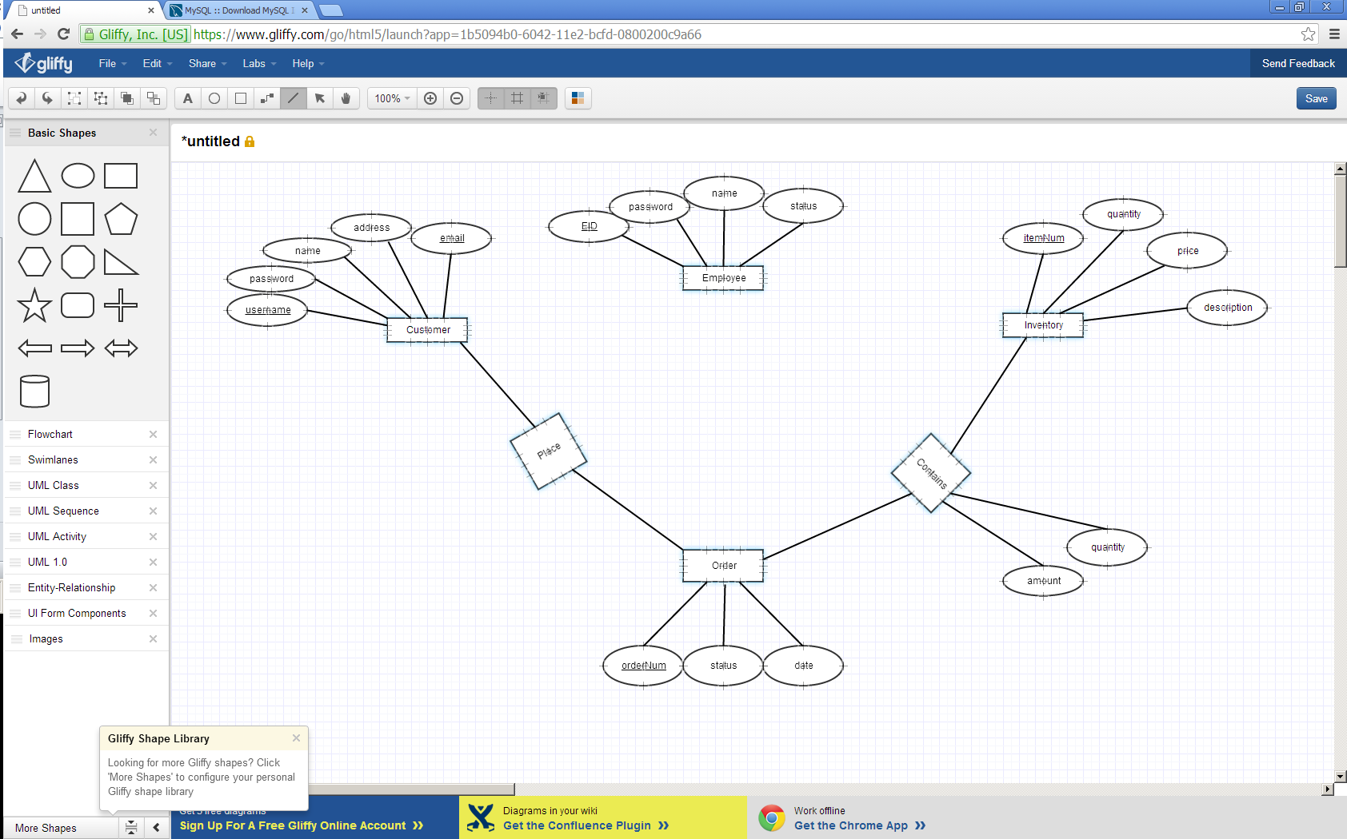
3. It will have the following schema design:
   1. Customer(username:string, email:string, password:string, name:string, address:string)
   2. Employee(eid:integer, password:string, name:string, status:string)
   3. Inventory(itemNum:integer, description:string, price:float, quantity:integer)
   4. PlaceOrder(username:string, orderNum:integer)
   5. Order(orderNum:integer, date:string)
   6. Contains(orderNum:integer, itemNum:integer, quantity:integer, amount:float)
   7. Cart(username:string, itemNum:integer, quantity:integer)
   8. View(username:string, search:string, itemNum:integer)